**Lab Assignment 1.**

1. I bought the book online from the campus store which was sent to my email. I opened the email where they sent me the link which had the following instructions how to install Visual Logic,

* **Step 1 - Obtain your VLSig File**  
  Enter the access code at: <http://www.visuallogic.org/course>. This will create a personalized VLSig file which be sent to you via email.   
  ***Save your VLSig file.***  
  **Step 2 - Download Visual Logic**  
  In addition to your VLSig file, you also need the Visual Logic executable file. You can download the Visual Logic executable file (or, the .exe file) from: <http://visuallogic.org/download>. It runs on any Windows machine and does not require any installation. Just double click the .exe file to launch Visual Logic. You will be asked to browse to your VLSig file to authenticate your work.

1. In addition to this, they provided me with the access code which was A0DB505972E7FEAE
2. The first thing I did was to click on this link in the first step which took me to this screen below

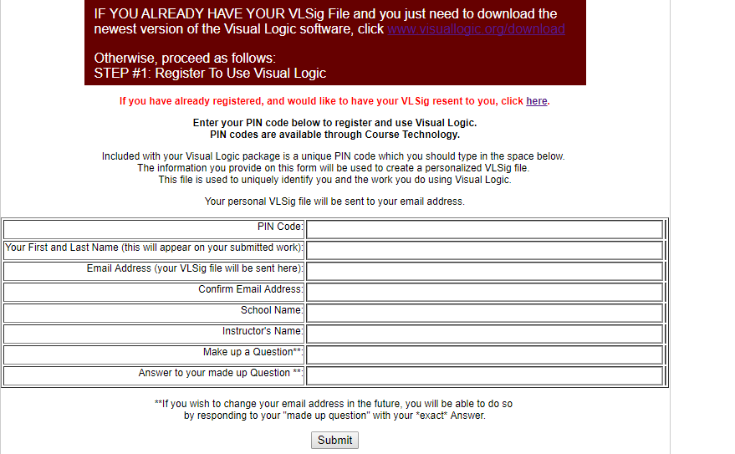

1. I entered my information in the above form
2. Then I submitted them by clicking on the submit bottom which took me to this following statement which is number six and number seven as you can see below in that order.
3. **After you register your PIN code, you can download and use Visual Logic.**

**7)** <http://www.visuallogic.org/download>

1. After download by clicking on above link. I came on to this screen below.

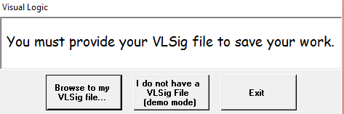

1. I browse the file which was downloaded to my computer which brought me to the final program below.

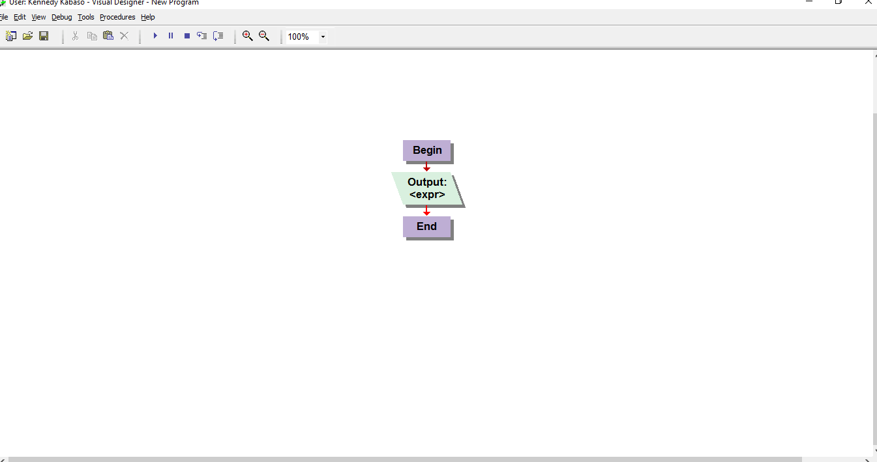**Experience and Comments**

I was very impressed with the way the program was running which was easy and straight forward. It was made to be user friendly more especially to the new programmer. I like the way some of the command are doing. I worked with the output one which enable someone to write and edit what they are trying to run and run the program after finish by click on the run command at the top of the program.

**Conclusion**

I am looking forward to enjoying this program which I will use during this class. In addition, I hope to do well with this application.